Fish Form and Function

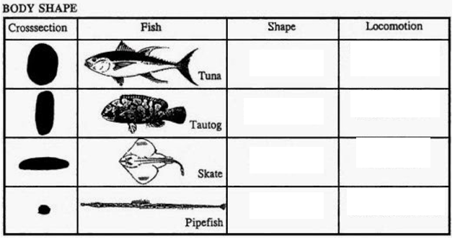

**Word bank:**

Compressiform fusiform filiform depressiform

Slithers through the water like a snake.

Quick speed for short distances.

Swims like a flying bird.

Fast-swimming in open water.

Answers:

