Methods of Commercial Fishing
Place the term that matches each type of commercial fishing in the image on the line. First try it without a word bank. Use the word bank at the bottom of the page if you need help. The answers are on the last page.
1.
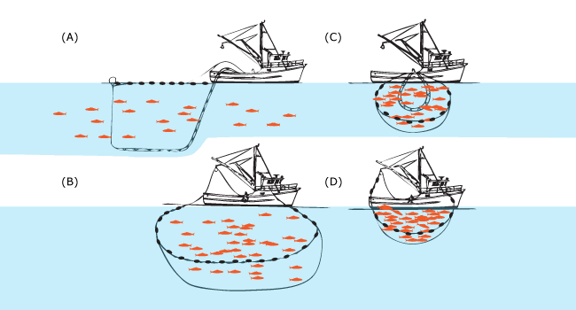________________________________

2. 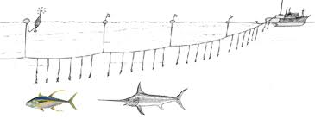 __________________________________

3. 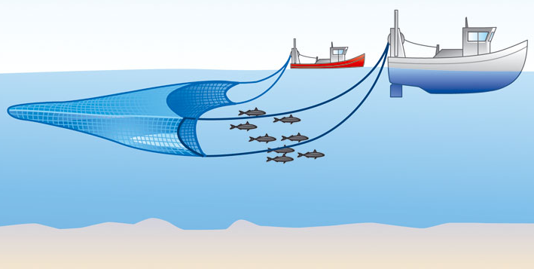 _______________________________

4. 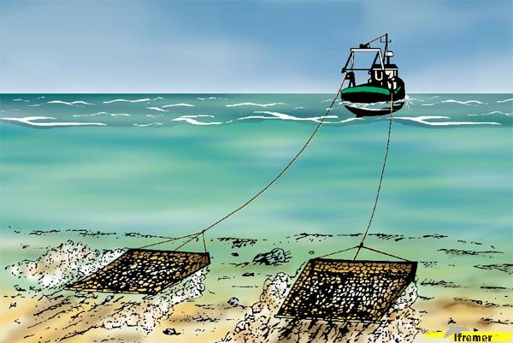 _____________________________

5. 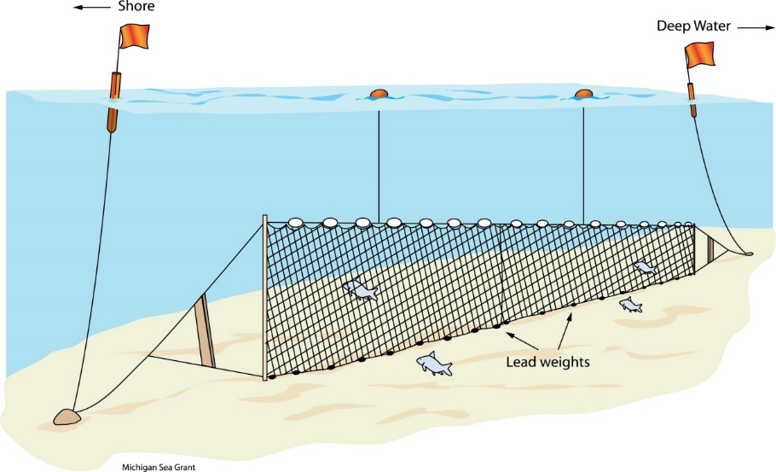 ___________________________

6. 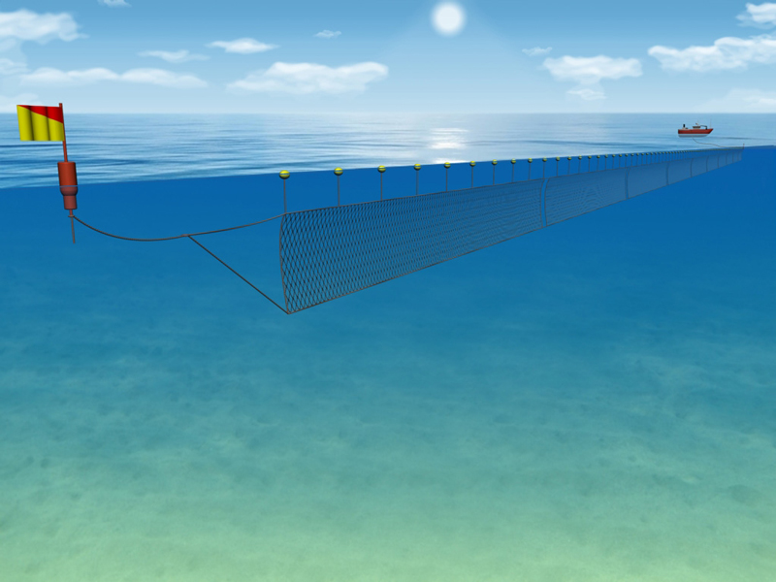 ________________________________
Word Bank:
Longline drift nets trawling
Gill nets purse seines dredging

Answers:
1. purse seine 2. Longline 3. Trawling 4. Dredging
5. gill nets 6. Drift nets

