Sharks and Rays Practice Quiz

1. Sharks and rays are in the phylum chordata and the class _____________.
a. osteoichythes b. chondricythes c. porifera d. cnidarian

2. The prefix “chondro” means: __________________
3. Name 3 ways sharks differ from other fish.
4. What is meant by a heterocercal tail?
5. Sharks have modified teeth called ________ scales.
6. Which of the following functions in sensing vibrations in the water?
a. Ampullae of Lorenzini b. lateral line c. placoid scales d. olfactory nerves
7. Which of the 4 terms for #6 is used for electroreception?
8. Without a swim bladder, how is a shark able to maintain its buoyancy?
9. Label the following fins on this shark image. Choose from: anal, dorsal, caudal, pectoral
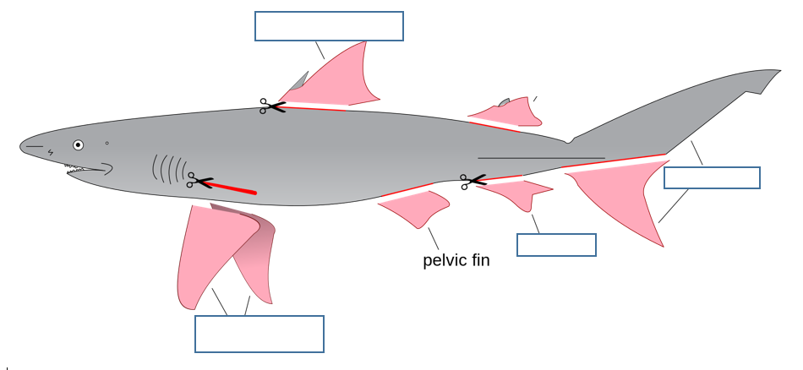

10. What is the largest species of ray?
11. List 2 threats to sharks’ existence.
12 matching
_____viviporous A. external egg that hatches without the mother
_____oviviviporous B. placental and has live birth
_____oviporous C. internal egg, young are released as live birth.
Answers
1. Sharks and rays are in the phylum chordata and the class _____________.
a. osteoichthyes b. chondrichthyes c. porifera d. cnidarian

2. The prefix “chondro” means: ___cartilage_____
3. Name 3 ways sharks differ from other fish. No gill cover, no swim bladder, placoid scales, internal fertilization
4. What is meant by a heterocercal tail? Upper portion of caudal tail is larger or longer
5. Sharks have modified teeth called __placoid_ scales all over their bodies.
6. Which of the following functions in sensing vibrations in the water? B.
a. Ampullae of Lorenzini b. lateral line c. placoid scales d. olfactory nerves
7. Which of the 4 terms for #6 is used for electroreception? A.
8. Without a swim bladder, how is a shark able to maintain its buoyancy? Very fatty and large livers
9. Label the following fins on this shark image. Choose from: anal, dorsal, caudal, pectoral

10. What is the largest species of ray? Manta ray, of course
11. List 2 threats to sharks’ existence. Overfishing (shark fin soup, cartilage, anticancer drugs), bycatch in fishing nets, poor reef management
12 matching
__B___viviporous A. external egg that hatches without the mother
_C____oviviviporous B. placental and has live birth
__A___oviporous C. internal egg, young are released as live birth.

